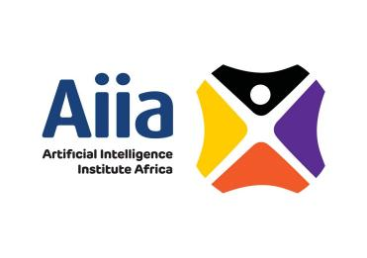
Artificial Intelligence Institute Africa
Hebert Chitepo Ave, Harare, Zimbabwe
+263 78 6434 988
admin@aiinstituteafrica.com
www.aiinstituteafrica.com

16 June 2026

Attention: Dr Manungo
ICT Practice
Harare, Zimbabwe

Dear Dr Manungo

REF: Invitation – AI for National Transformation: Zimbabwe 2.0 & AI Tech Forum Summit

We are pleased to invite you to attend and participate at the following summit:
The AI Tech Forum 2026 will take place from 16–17 June 2026 at Masvingo Urban Lifestyle Hotel, underthe theme: “
Engineering the Future: Mastering Next-Generation AI Systems in Practice at Scale.”
This will be followed by the AI for National Transformation: Zimbabwe 2.0 Summit, scheduled
for 17–18 June 2026, under the theme:
“Leveraging AI for Innovation, Policy, and Inclusive National Development.”

We advise that the Minister of Information Communication Technology (ICT), Postal and Courier Services,Hon. Dr. Tatenda A. Mavetera, will be the Guest of Honor and The Minister of Skills Audit and Development,Hon J. Muswere will be key note Speaker. Hosted by the Artificial Intelligence Institute Africa (Aiia) in partnership with Ministry of ICT and Zimpapers, the Summit brings together key stakeholders to unpack implementation.

Your leadership greatly enriches conversations that shape AI adoption to drive NDS2.

Please find attached the pricing for your consideration. Please also note that the cost related to accessing the summit are covered however you will incurr the cost of accommodation and meals.

For further details, kindly contact:
AI Institute Africa: +263 71 777 0666
We sincerely hope you will join us in what promises to be a defining moment for AI advancement in Zimbabwe.
Yours sincerely,
Dr Dennis Magaya
Chairman – AI Institute Africa : +263 71 777 0666
